**To**

BooTails Petspa & Mobile Grooming  
jinnaihk@yahoo.com  
9049 Silang Bypass Road Purok1 Biga1 Silang Cavite 4118 Manila, Philippines  
  
Dear BooTails Petspa & Mobile Grooming,

Get ready to unleash your furry (or feathered, or scaled!) friends' full potential with Unleash, the all-in-one pet lifestyle app! We're excited to invite you to be among the first 50 merchants to join our vibrant community and tap into a rapidly growing market of passionate pet owners.

Unleash is more than just an app, it's a pet universe:

* Social media for pets: Create profiles, share adorable photos and videos, and connect with other pet parents.
* Thriving marketplace: Sell anything pet-related, from food and accessories to services like training, dog walking, and vet care.
* Engaging games: Keep pets (and their owners!) entertained with fun, interactive games featuring virtual companions (coming soon).
* Pet dating, if you will: Help loveable furry singles find their perfect match and create happy tails (coming soon).
* Trusted resource center: Provide accurate and insightful information on pet care, health, and wellness.

As a launch partner, you'll unlock exclusive benefits:

* Free app placement: Showcase your business prominently within the app for the first 3 months, maximizing visibility and attracting new customers.
* Geo-managed advertising: Target your ideal audience with precise location-based advertising, ensuring your message reaches the right pet parents at the right time.
* Intuitive platform & easy payment process: Make online selling effortless with our user-friendly interface and seamless payment integration.
* Freebies for pet owners: Generate buzz and build brand loyalty by offering exclusive freebies or discounts to Unleash users to visit your storefront. Partner with us so you can create irresistible deals, like sample packs of your popular dog treats or complimentary wellness consultations.

Limited spots available! Be among the first 50 merchants to onboard and unleash your business potential on Unleash. Simply head over to <https://forms.gle/ZvZaadAMNqgBNeok7> or scan the QR code below to register as a partner merchant.

Don't miss this chance to connect with millions of pet lovers and grow your business alongside a thriving community.

We can't wait to welcome you to the Unleash pack!

Sincerely,  
The Unleash Team  
  
Partner-merchant application form:  
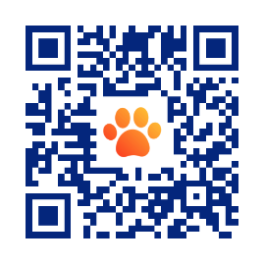  
  
Download the app here:  
